Business Idea – Detailed description

The concept of my business idea involves creating a peer-to-peer marketplace that connects locals who want to buy goods from overseas that they cannot attain locally and travelers who have extra baggage space.

The users of this service involve anyone who wants items that are country-exclusive, people who refuse to pay for overpriced shipping and travelers who have extra baggage space and are willing to deliver or post the products for the “requesters”.

The requirements of the customers are to ensure that they ultimately receive the goods that they are paying for. This service will eliminate the need for customers to search for friends who are in those countries where the goods originate and have to wait until they are flying to the country where the customers are based. Not only will this service provide people with what they desire regardless of where it is from, it will also be a quick process as travelers who accept the goods have to be travelling within that week.

The problem is that at times, customers want goods that they do not have immediate access to due to restricted availability or high shipping charges. This service allows them to go onto the platform and request for their desired item from a specific country. The role of the traveler, who is already traveling from the country where the product is available to the country where the customer is based, is to accept the request from the customer, acquire the goods and then deliver the goods to the customer via shipment post or physical delivery.

There are also several different solutions to the problem of people not being able to acquire their desired products. First is the mentioned concept above, second is starting a forwarding shipping service where consumers can post goods to an address and the service forwards the goods to the customer. The last solution can be working with a postal service and providing customers overseas for overall cheaper shipping costs at an annual fee.

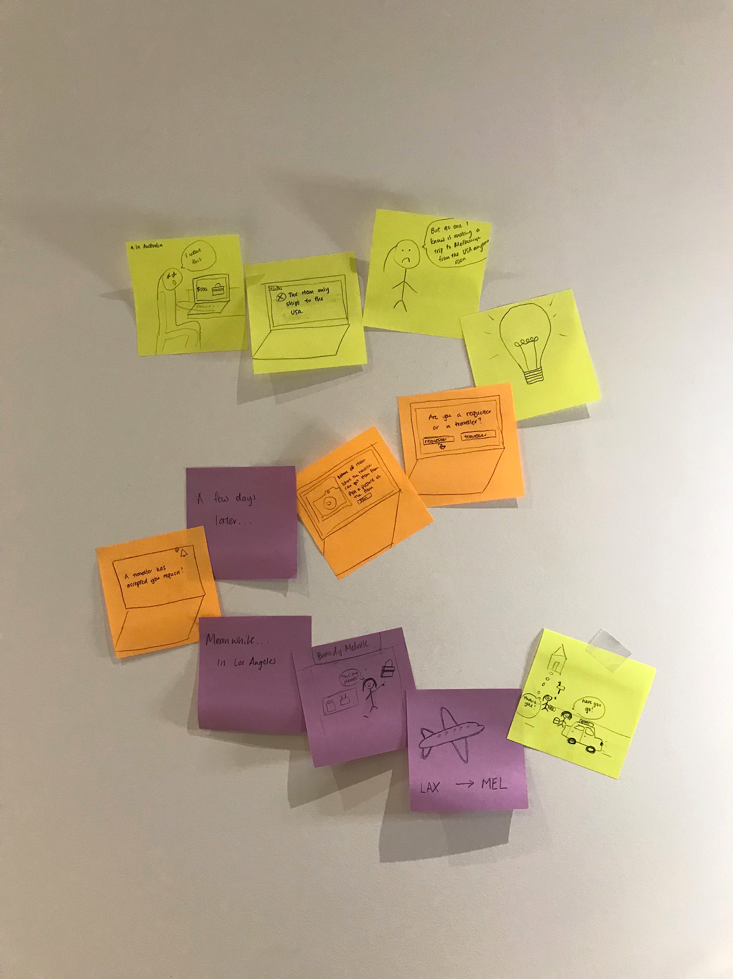

|  |  |
| --- | --- |
| **Use** – of the website/app | |
| **Looking** | * People are looking for where they can request for an item * People are looking for travelers travelling their direction from a specific country * Information page that explains steps as well as concept |
| **Touching** | * Most touching will occur between humans and devices * They will use their devices to input their requests and travelers from the other end are able to accept the request if they want to. * Travelers will retrieve the item requested by customer * Once the traveler arrives at the item’s destination country, they will either pass the item onto the customer via physical interaction or via post * Once item is delivered, customer must confirm on the website that they have indeed received the item in order for the traveler to receive their payment |
| **Talking** | * Customers must communicate with the travelers regarding the item they want and where to get it and how they want it to be delivered to them * If customers or travelers are confused as to how the website works, they can talk to a chat bot on the page |
| **Hearing** | * The website does not require any sound |
| **Standing** | * Standing – when the traveler purchases the goods for the customer they stand and wait in line to pay if they purchase goods physically |
| **Taking** | * Travelers take goods with them onto flight and then passes it to the customer at destination or takes goods and ships the goods to customer |